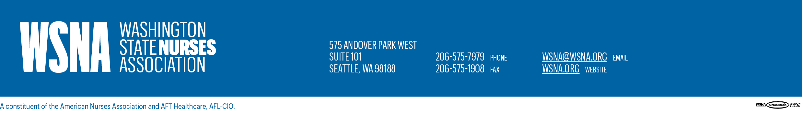

Oct. 19, 2018 | VIA USPS FIRST CLASS MAIL AND FACSIMILIE
Ketul Patel, CEO
Ruth Flint, Director of Nursing Services/COO
St. Joseph Medical Center
1717 S. “J” St.
Box 2197
Tacoma, WA 98405-2197

RE: Workplace Violence

Dear Mr. Patel and Ms. Flint,

As you are no doubt aware, a patient in the mental health unit at Saint Joseph Medical Center has repeatedly assaulted and threatened to kill nurses and other employees. Several nurses have already suffered significant injuries.

To date, the Medical Center has failed to implement appropriate measures to reasonably prevent and protect employees from workplace violence, in violation of the Employer’s legal obligation to furnish employees a place of employment free from recognized hazards causing or likely to cause serious injury or death to employees. Indeed, we are informed that this patient is no longer restrained or secluded, and essentially has access to the entire unit. This situation is intolerable.

The Washington State Nurses Association hereby demands that the Employer immediately implement all necessary measures to prevent and protect nurses and other employees from violence and threats of violence in the workplace.

Please be advised that until this clear and present hazard is corrected, nurses may be forced to exercise their legally-protected right to refuse to work under these dangerous conditions.

In addition, in order to meet our representation obligations under the Act, WSNA requests the following:

- Complete copies of all documents relevant to the violent incidents in the Inpatient Mental Health Unit from Aug. 1, 2018 to current.
- All reports involving nurse safety over the past three years, including any reports related to investigations or government filings.
- All documents reflecting communications with law enforcement regarding incidents in the Inpatient Mental Health Department from Aug. 1, 2018 to current.
- Copies of any communications between the Medical Center and any bargaining unit employee, including any victims subject to violence, from Aug. 1, 2018 to current.
- The Medical Center’s OSHA 300 logs for the past three years.
- With regard to the Medical Center’s Safety Committee, please provide all documents reflecting the members of the Committee (by name and job title), Committee meeting dates, attendees, minutes, quarterly and annual reports, assessments and educational activities for each month in the past three years.
- Please provide all documents showing the number of security personnel assigned by times and shifts by month over the past three years, the job title, job description, and employment period of each security personnel; whether each is an employee or contractor, their regular assignments and work locations, rules and restrictions regarding their conduct in the event of workplace violence, and the contract(s) between the Medical Center and any Company providing security personnel.
- All records reflecting work-related injuries to represented nurses by month and unit over the past three years.

Please provide the above requested information to WSNA Nurse Representative Sara Frey by Oct. 29, 2018.

Sincerely,
Christine Watts
Christine Watts, MN, RN
Senior Director of Labor
Washington State Nurses Association
(206) 575-7979, ext. 3016
cwatts@wsna.org

C: Dian Davis, RN, WSNA Local Unit Chair

Sara Frey, JD, BNS, RN, WSNA Nurse Representative

Sharon Royne, Senior Vice President, Human Resources

Jill Karon-Ross, Human Resources Director

